Essential Elements

Home/Introduction
- Professional Bio: Brief overview of background, interests, and experience.
- Headshot/Avatar: Professional photo or avatar.
- Tagline/Summary: Concise statement highlighting expertise.

About Page
- Brief Bio: Concise summary of experience, skills, and career goals.
- Contact Information: Email, phone number, and social media links.
- Resume/CV: Downloadable or linked version.

Projects
- Project Showcase: Curated selection of best projects with:
  - Project descriptions
    - Problems Solved
    - Outcomes Achieved
  - Screenshots/images
  - Live demos/GitHub repositories
  - Technologies used
- Case Studies: In-depth analyses of specific projects.

Skills
- Technical Skills: List of programming languages, frameworks, databases, and tools.
- Soft Skills: Relevant non-technical skills (communication, teamwork, problem-solving).

Experience
- Work Experience: Brief summary of work history (job titles, company names, dates).
- Personal Projects: Notable personal projects or open-source contributions.

Education
- Formal Education: Degrees, certifications, or relevant courses.
- Online Courses/Training: Relevant online courses, tutorials, or certifications.

Contact/Networking
- Contact Information: Email, phone number, and/or contact form.
- Social Media Links: Professional social media profiles (LinkedIn, GitHub, Twitter).

Blog (Optional)
- Articles/Tutorials: Share knowledge and expertise.
- Industry Insights: Thoughts on industry trends, news, or best practices.

Design and User Experience
- Responsive Design: Mobile-friendly and responsive.
- Easy Navigation: Clear and intuitive navigation menu.
- Visual Hierarchy: Headings, images, and whitespace.

Testimonials/Recommendations
- Quotes from Clients/Colleagues: Positive feedback.

Call to Action
- Encourage Contact: Clear call to action (e.g., "Contact Me" or "Hire Me").

SEO Optimization
- Improve Visibility: Relevant keywords, meta descriptions, proper HTML structure.

Additional Tips
- Keep it Up-to-Date: Regularly update with new projects and experiences.
- Showcase Personality: Inject personality through design, tone, and content.
- Make it Easy to Scan: Clear headings, bullet points, concise paragraphs.
- Test and Iterate: Test for usability and iterate on improvements.

Design Brief

Colors

Typography

Iconography

Logos

Inspiration:
https://www.shutterstock.com/blog/art-deco-graphic-design-techniques
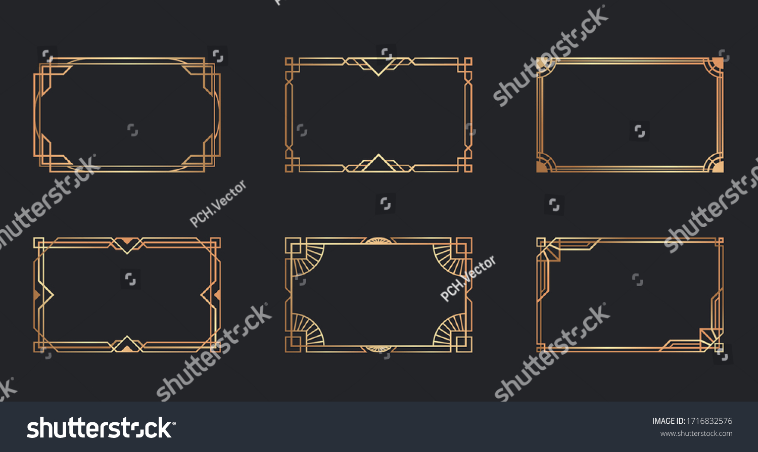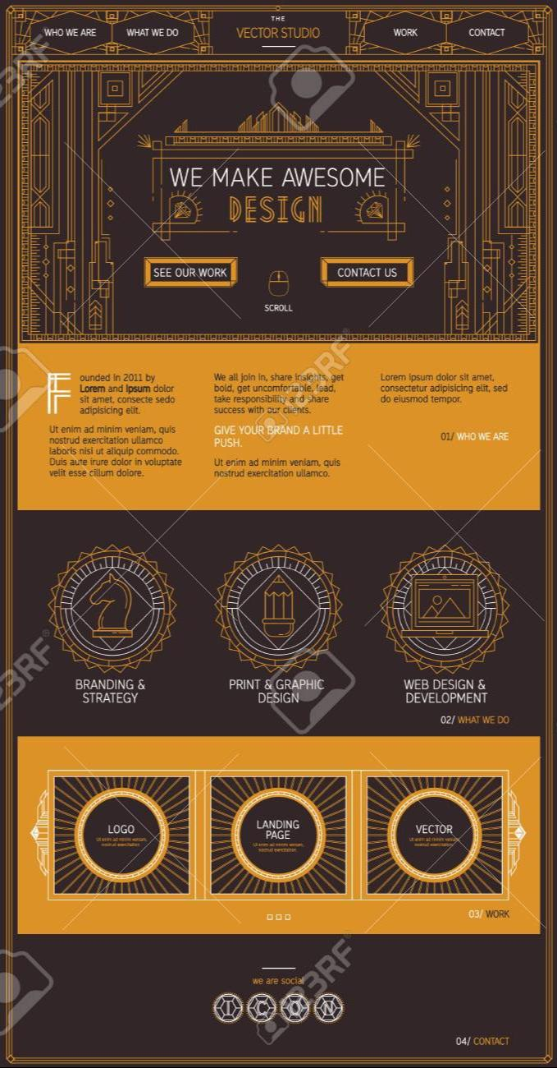
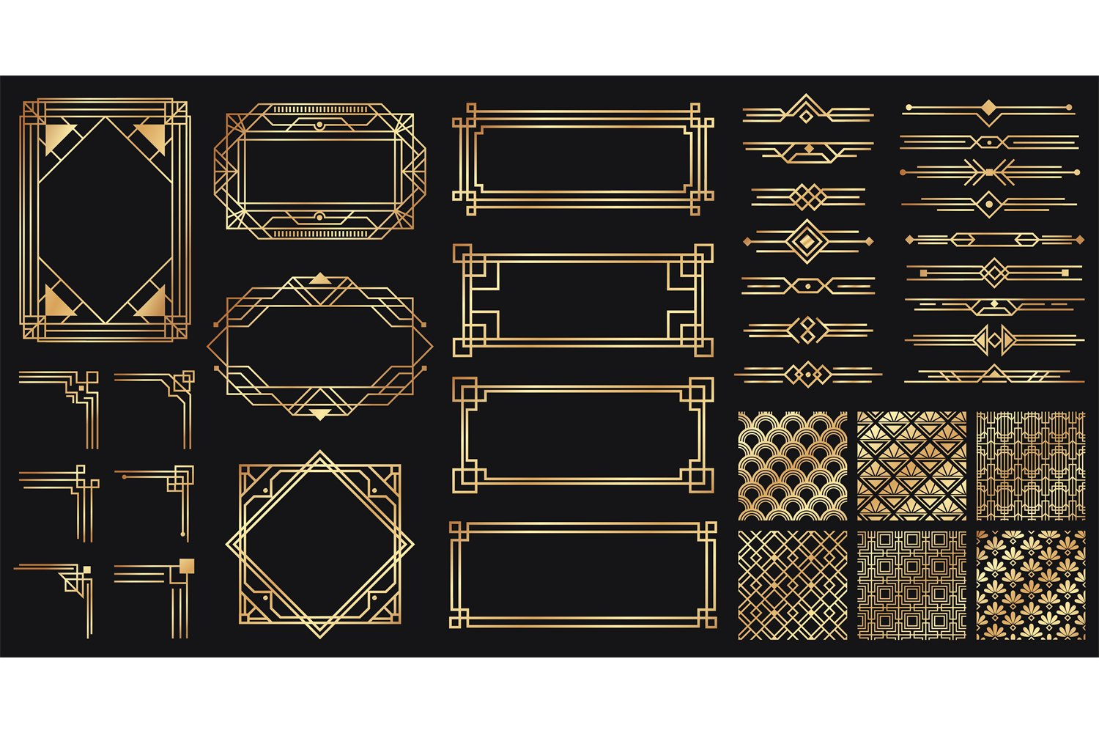

Projects

Projects:

Temporary Assignment

Description:
Problem, Solution, and Result. Problem, Solution, and Result. Problem, Solution, and Result. Problem, Solution, and Result. Problem, Solution, and Result. Problem, Solution, and Result. Problem, Solution, and Result. Problem, Solution, and Result. Problem, Solution, and Result. Problem, Solution, and Result. Problem, Solution, and Result. Problem, Solution, and Result. Problem, Solution, and Result. Problem, Solution, and Result. Problem, Solution, and Result. Problem, Solution, and Result.

Technologies:

Login Info?:

Demo: https://ace-d-baugh.github.io/TA-Projects/

Code: https://github.com/ace-d-baugh/TA-Projects

Yelp Camp

Description:
Problem, Solution, and Result. Problem, Solution, and Result. Problem, Solution, and Result. Problem, Solution, and Result. Problem, Solution, and Result. Problem, Solution, and Result. Problem, Solution, and Result. Problem, Solution, and Result. Problem, Solution, and Result. Problem, Solution, and Result. Problem, Solution, and Result. Problem, Solution, and Result. Problem, Solution, and Result. Problem, Solution, and Result. Problem, Solution, and Result. Problem, Solution, and Result.

Technologies:

Login Info?:

Demo: https://acieffe-yelp-camp.onrender.com/

Code: https://github.com/acieffe/Udemy-YelpCamp

Repair Shop

Description:
Problem, Solution, and Result. Problem, Solution, and Result. Problem, Solution, and Result. Problem, Solution, and Result. Problem, Solution, and Result. Problem, Solution, and Result. Problem, Solution, and Result. Problem, Solution, and Result. Problem, Solution, and Result. Problem, Solution, and Result. Problem, Solution, and Result. Problem, Solution, and Result. Problem, Solution, and Result. Problem, Solution, and Result. Problem, Solution, and Result. Problem, Solution, and Result.

Technologies:

Login Info?:
Standard User
- username: [mozart]
- password: [Password01]
Admin User
- username: [bach]
- password: [Password01]

Demo: https://gryffindor-bcrs.onrender.com/#/

Code: https://github.com/ace-d-baugh/gryffindor-bcrs

Contact Pro (World’s Address)

Description:
Problem, Solution, and Result. Problem, Solution, and Result. Problem, Solution, and Result. Problem, Solution, and Result. Problem, Solution, and Result. Problem, Solution, and Result. Problem, Solution, and Result. Problem, Solution, and Result. Problem, Solution, and Result. Problem, Solution, and Result. Problem, Solution, and Result. Problem, Solution, and Result. Problem, Solution, and Result. Problem, Solution, and Result. Problem, Solution, and Result. Problem, Solution, and Result.

Technologies:

Login Info?:

Demo: http://ace-baugh-worldsaddress.up.railway.app

Code:

Animations

Description:
Problem, Solution, and Result. Problem, Solution, and Result. Problem, Solution, and Result. Problem, Solution, and Result. Problem, Solution, and Result. Problem, Solution, and Result. Problem, Solution, and Result. Problem, Solution, and Result. Problem, Solution, and Result. Problem, Solution, and Result. Problem, Solution, and Result. Problem, Solution, and Result. Problem, Solution, and Result. Problem, Solution, and Result. Problem, Solution, and Result. Problem, Solution, and Result.

Technologies:

Login Info?:

Demo: https://ace-d-baugh.github.io/Animations/

Code: https://github.com/ace-d-baugh/Animations

Teams Tracker

Description:
Problem, Solution, and Result. Problem, Solution, and Result. Problem, Solution, and Result. Problem, Solution, and Result. Problem, Solution, and Result. Problem, Solution, and Result. Problem, Solution, and Result. Problem, Solution, and Result. Problem, Solution, and Result. Problem, Solution, and Result. Problem, Solution, and Result. Problem, Solution, and Result. Problem, Solution, and Result. Problem, Solution, and Result. Problem, Solution, and Result. Problem, Solution, and Result.

Technologies:

Login Info?:

Demo: https://ace-d-baugh.github.io/teams-stand-up-tracker/

Code: https://github.com/ace-d-baugh/teams-stand-up-tracker

Node Bucket (To-Do)

Description:
Problem, Solution, and Result. Problem, Solution, and Result. Problem, Solution, and Result. Problem, Solution, and Result. Problem, Solution, and Result. Problem, Solution, and Result. Problem, Solution, and Result. Problem, Solution, and Result. Problem, Solution, and Result. Problem, Solution, and Result. Problem, Solution, and Result. Problem, Solution, and Result. Problem, Solution, and Result. Problem, Solution, and Result. Problem, Solution, and Result. Problem, Solution, and Result.

Technologies:

Login Info?: Emp ID: 1011

Demo: https://baugh-nodebucket.onrender.com/

Code: https://github.com/ace-d-baugh/nodebucket/

